CS 255 System Design Document Template

UML Diagrams

UML Use Case Diagram
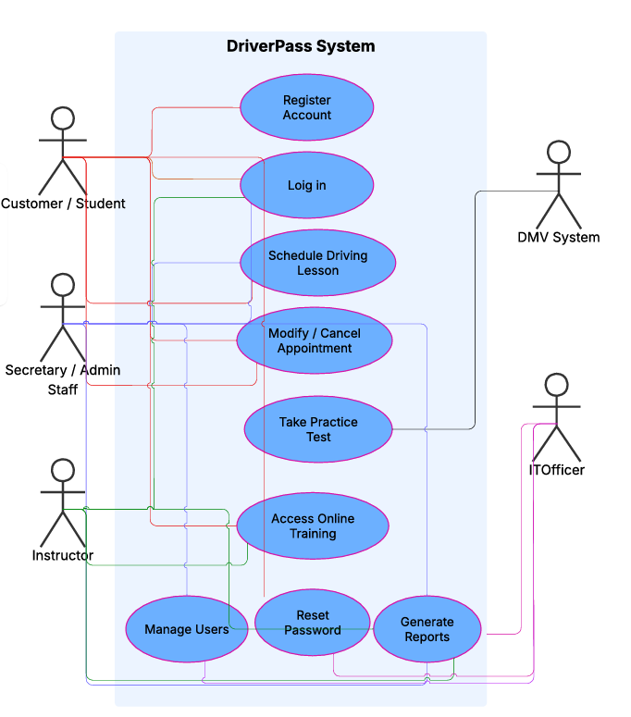

UML Activity Diagrams
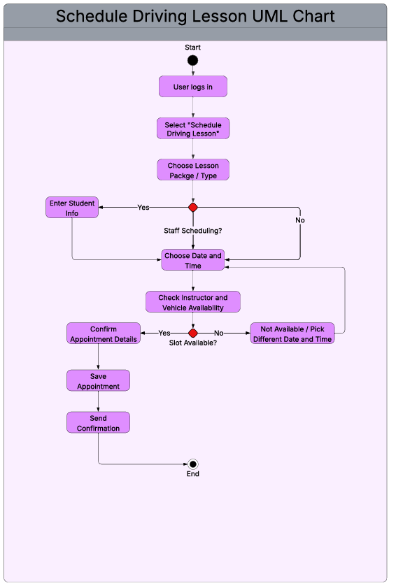
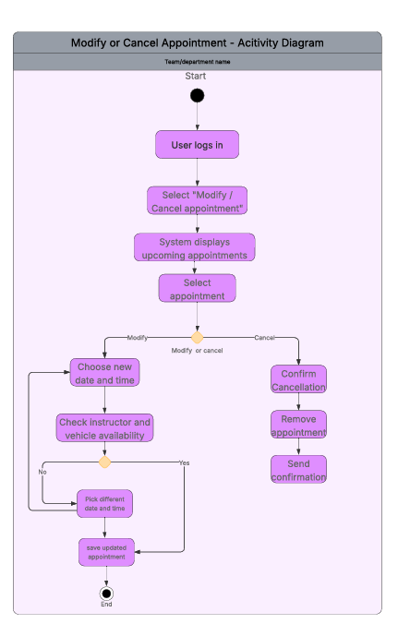

UML Sequence Diagram
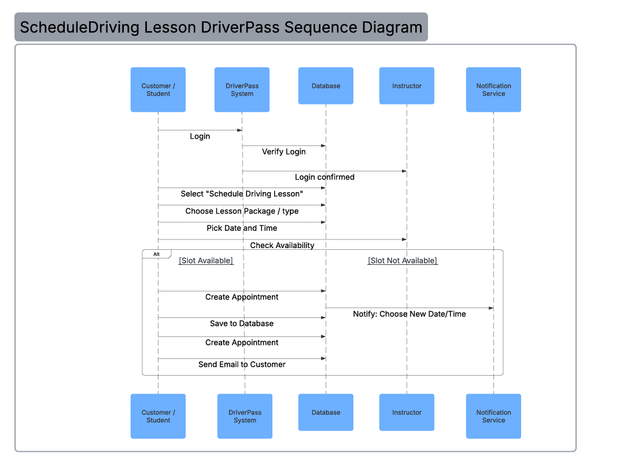

UML Class Diagram
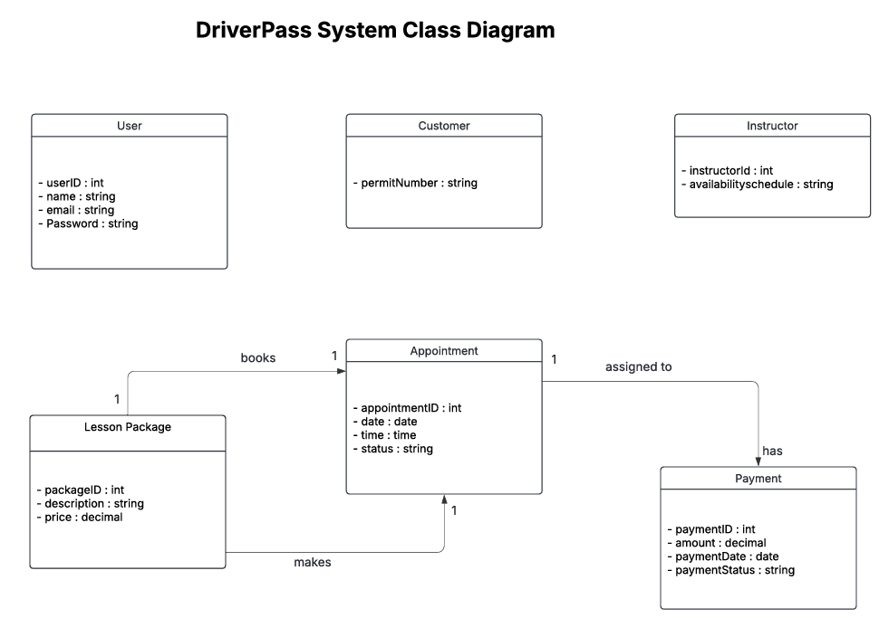

Technical Requirements
The DriverPass system will require both hardware and software components to function effectively. Because the system is web-based, users such as customers, instructors, and administrative staff will need access to a computer, tablet, or smartphone with a reliable internet connection and a modern web browser (such as Chrome, Edge, or Safari).
On the software side, the system will require a secure web server to host the DriverPass application and a database server to store user accounts, lesson packages, appointments, instructor schedules, and payment information. The system must support secure login functionality and encrypted data transmission to protect user information.
The system will also require integration with a payment processing service to handle online payments and a notification service to send confirmation emails to customers. These services ensure that appointments are properly scheduled, payments are recorded, and users receive confirmation of their transactions.
From an infrastructure perspective, the system should be hosted in a cloud environment to ensure availability, scalability, and data backup. Regular database backups and security monitoring will be necessary to maintain reliability and protect sensitive customer data.
Overall, the technical requirements support a secure, reliable, and accessible scheduling platform that meets DriverPass’s operational needs.

